# Inception Document

# ----System Monitoring Management

## Overview (vision and business control)

How does a user know the performance of his computer’s system? How many percentage of CPU usage do the current applications use? How much space is left of the computer’s memory? In order to realize these functions and help users to monitor their computers’ system immediately and easily, our team will develop an APP which can be downloaded to mobile phones. Therefore, users can monitor computers’ system performance without time and place limit.

## Functions Analysis --- Use-Case model

* Main use-case. This main use-case contains users and administrator(s). It shows a link between user and the administrator to system monitoring management system. There are different functions to the user and administrator.

**Char 1**

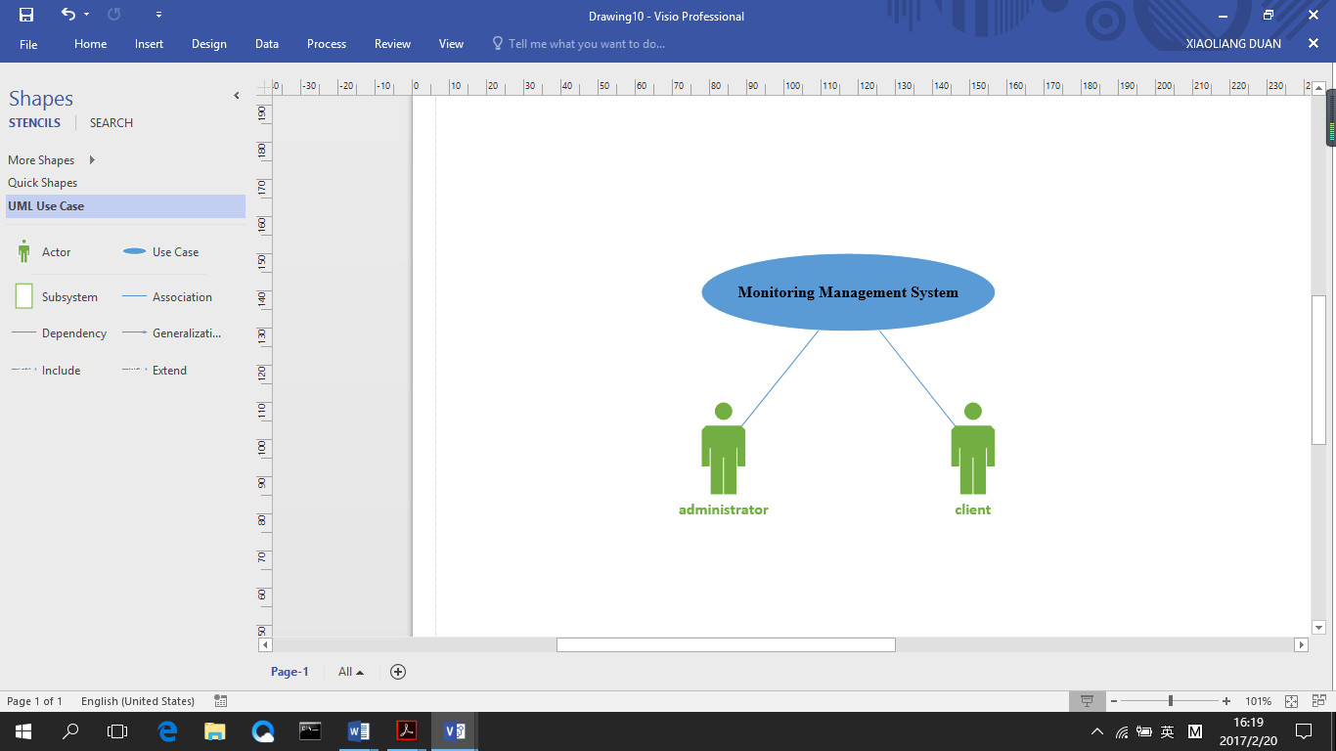

* Client sub-system. This sub-system is the user’s operations which is a user sided view. This diagram shows that the user has to register into the system monitoring management system firstly. The client can view all the detail of this system and check the information about his system. He can update his profile when login the system. He can also check the alarm information that the system had sent to him. In addition, he can view CPU usage, memory usage and storage usage easily in this system.

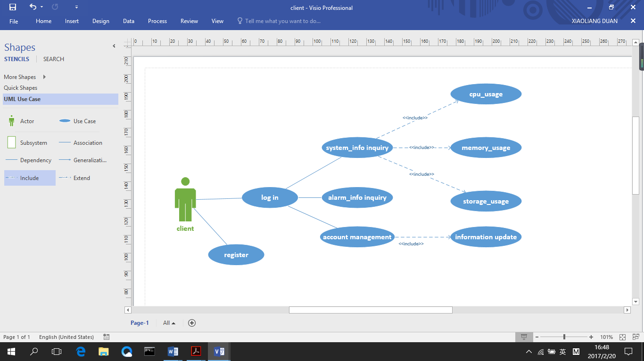**Char 2**

* Administrator sub-system. The diagram below shows all features, categories and defining administrator side view. At first, the administrator must have valid ID to log in and after that he or she can manage clients’ information (add, deletion, edit and inquiry). Moreover, the administrator can manage the system information from the background. He can configure cluster, IP address, account and port and at the same time, he can check system usage of the clients. In addition, the administrator can also review and manage alarm information

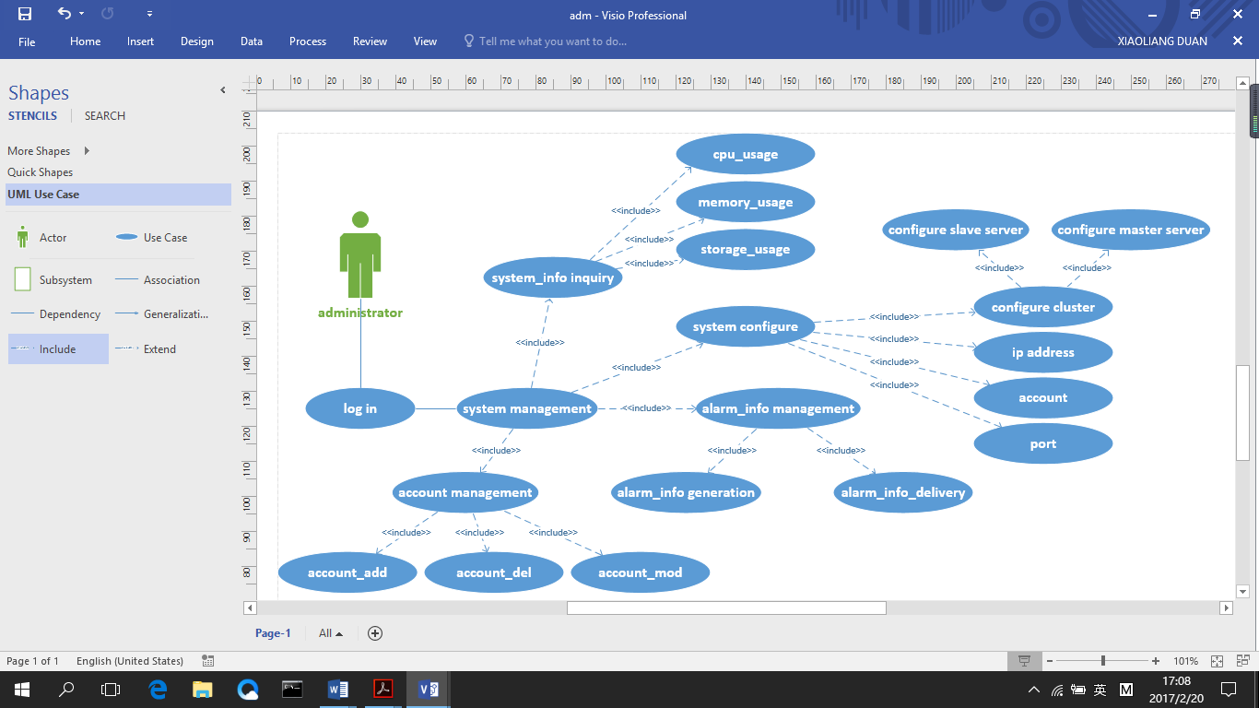**Char 3**

## Supplementary specification

Server log supplement is a very important function in this system development. The log is an effective means of reflecting its operation. For the management of the log, can it can be recorded locally or remotely. We prefer to the local log which is more efficient than remote log. Using server log can help us to analyze the situation of the new system.

## Glossary

## Risk List and Management Plan

1. **Prototypes and proof of concepts**

## Iteration Plan

In the first elaboration, we plan to realize the main functions. For the administrator, he can manage all the information of the system. He can inquire the usage of CPU, memory and storage either the master server or slave server. He can manage the account of clients including update, delete and addition. He can also configure different clusters, IPs and ports. For the client, he can manage his account, inquire system’s usage and receive alarm massage.

In the next elaboration, we plan to materialize these functions and improve the disadvantages

## Phase plan and software development plan

In phase 1, we have finished the preliminary design and figured out the main functions of this system. In next phase, we are going to focus on developing this software including elementary implementation of some certain functions and some UI design. The languages we are going to use are C, JavaScript and HTML and the development tool will be Visual Studio. Moreover, the database management tool is MySQL.

In addition, our group has cleared our respective tasks. All our team members giving their best shot, anyone stuck in any phase we work out together to get it done, some of us had experience of designing software before, but some of us have no much experience of how to design. Therefore, our team members plan to do the familiar part individually and unfamiliar parts together. We will have meetings regularly to make sure everyone understand his (her) task, and improve our abilities together.

## Development Case

Customization of UP steps and artifacts for the project